


NARAYANA ENGINEERING COLLEGE:: GUDUR
(AUTONOMOUS)

Class : I B.TECH - ISEM Academic Year :2023-24
Course Title : Engineering Graphics
Faculty : Dr. B.V. Krishnaiah Branch :Common to all Branches

MODULE-1

S.NO | QUESTION BANK | CO | BL |  | MARKS
- 1 | a). Construct the Regular Pentagon of each side equal to 50mm  b). Construct the Regular Hexagon of each side equal to 50mm | 1 | 1 |  | 7+7
- 2 | Construct the Regular Polygons from Square to Octagon in single diagram, each side equal to 40mm. | 1 | 2 |  | 14
- 3 | Construct an Ellipse when the distance between focus and the directrix is 50 mm and Eccentricity is 2/3. Draw a Tangent and Normal at any on the curve. | 1 | 2 |  | 14
- 3 | Construct a Parabola when the distance between focus and the directrix is 60 mm. Draw a Tangent and Normal at 40 mm from directrix line. | 1 | 3 |  | 14
- 4 | Construct a Hyperbola when the distance between focus and directrix is 60 mm, the Eccentricity is 4/3. Draw a Tangent and Normal at any point on the curve. | 1 | 3 |  | 14
- 5 | A coin of 40 mm diameter rolls over a horizontal table without slipping. A point on the circumference of the coin is in contact with the table surface in the beginning and after one complete revolution. Draw the path traced by the point. Draw a tangent and a normal to the curve at any point on the curve. | 1 | 2 |  | 14
 | Draw an Epi-Cycloid of rolling circle 40 mm diameter (2r) which rolls outside of another circle (Base circle) of 150mm diameter (2R) for one complete revolution. Draw a Tangent and Normal at any point on the curve. | 1 | 2 |  | 14
 | Draw a hypo-cycloid of a circle for 40mm diameter, which rolls inside of another circle of 200 mm diameter for one complete revolution in counter clock-wise. Draw a tangent and normal at any point on the curve. | 1 | 2 |  | 14
 | A coir is unwound from a dram of 40 mm diameter. Draw the locus of the free end of the coir for unwinding through an angle of 360⁰. Draw also a Normal and Tangent at any point on the curve. | 1 | 1 |  | 14
 | Construct a plain scale to show in meters when 1 centimeter represents 4 meters and long enough to measure up to 50 meters. Find RF and mark on your scale a distance of 36 meters. | 1 | 3 |  | 14
 | Construct a diagonal scale of RF= 1:32,00,000 to show kilometers and long enough to measure up to 400 km. Show the distance of 257 km and 333 km on your scale. | 1 | 3 |  | 14
 | Construct a vernier scale to read meters, decimeters and centimeters and long enough to measure up to 4 meter. RF of the scale is 1/20. Mark onyour scale a distance of 2.28 meters. ( Backward/ Retrograde Vernier) | 1 | 3 |  | 14
 | MODULE-2
- 6 | Draw the projections of the following points on the same ground line, keeping the projectors 25 mm apart.  - 40 mm above the HP and 20 mm behind the VP.  - 40 mm above the HP and 25 mm in front of the VP.  - In the VP and 40 mm above the HP.  - 25 mm below the HP and 25 mm behind the VP.  - 15 mm above the HP and 50 mm behind the VP.  - 40 mm below the HP and 25 mm in front of the VP.  - In both the HP and the VP. | 2 | 3 |  | 14
- 7 | A Point ‘P’ is 35 mm above the HP and 50 mm in front of the VP. Another point Q is 25 mm behind the VP and 40 mm below the HP. Draw the projections of P and Q keeping the distance between their projections equal to 90 mm. Draw straight lines joining (i) their top views and ii) their front views. | 2 | 3 |  | 14
 | Two points A& B are on HP, the point A is 40 mm in front of VP while point B is behind VP. The distance between two projectors is 75 mm. Joining with the straight line their top views makes an angle 45⁰ with XY reference line. Determine the distance of the point B from VP. | 2 | 3 |  | 14
- 8 | a). A line AB 70mm long is inclined 40⁰ HP and parallel to 30 mm in front of VP. The end A is 15 mm above the HP and 20 mm in front of VP, Draw the projections of straight line .  b). A line PQ 70mm long is parallel to 40 mm above HP and inclined to VP. The end P is 20 mm, end Q is 50 mm in front of VP respectively . The Draw the projection of the line. Determine the inclination with the VP. | 2 |  | 3 | 7+7 | 3 | 10
- 9 | A line AB of 70 mm long, is inclined 30⁰ to HP and 45⁰ to VP. The end A is 20 mm above the HP 10 mm in front of VP. Draw the projections of the straight line. | 2 | 3 |  | 14
- 10 | A line AB of 70 mm long, has its end A at 15 mm above H.P and 20 mm in front of V.P. Its front view and top view measure 50 mm and 60 mm respectively. Draw the projections of the line and determine its inclinations with H.P. and V.P | 2 | 2 |  | 14
- 11 | The midpoint of a straight line AB is 60mm above HP and 50mm in front of V.P. The line measures 80mm long and inclined at an angle of 30⁰ to H.P and 45⁰ to V.P. Draw its projections | 2 | 1 |  | 14
- 12 | A line AB 120 mm is inclined at 45⁰ to HP and 30⁰ VP. The mid-point C isin VP and 20 mm above the HP. The end A is in third quadrant and end B is in I quadrant. Draw the projections of the straight line. | 2 | 2 |  | 14
- 13 | A regular Pentagonal Plane of 30mm side has one side on the ground. The plane is inclined 45⁰ to the HP and perpendicular to VP. Draw its projections. | 2 | 3 |  | 14
- 14 | Draw the projections of the circle of 50 mm diameter, having it’s plane vertical and inclined at 30° to VP . It’s center is 30mm above the HP and 20mm in front of VP. | 2 | 2 |  | 14
 | Draw the projections of regular Hexagon of each side 30mm having one of the sides in the HP, and its surface makes an angle 45⁰ HP. | 2 | 3 |  | 14
- 15 | A square ABCD of 50 mm side has its corner A in the HP, its diagonal AC is inclined 30⁰ to HP and diagonal BD is inclined 45⁰ to VP and parallel to HP. Draw its projections. | 2 | 2 |  | 14

S.NO | MODULE-3 | CO | BL |  | MARKS
1 | Draw the projections of a hexagonal prism side of base 30mm and height 60mm having one of its rectangular faces resting on HP. Its axis is perpendicular to the VP. | 3 | 1 |  | 14
2 | Draw the projections of a cylinder of base 40 mm diameter and axis 50 mm long, resting with its base on the HP. Its axis is parallel 50 mm in front of VP. | 3 | 2 |  | 14
3 | Draw the projections of a hexagonal pyramid side of base 30 mm and height 60 mm. The base is resting on HP and axis is parallel to VP. One of its base edges is making and angle 30⁰ to VP. | 3 | 2 |  | 14
4 | A pentagonal prism with side of base 30mm and axis 60mm long is resting with an edge of its base on HP, such that the rectangular face containing that edge is inclined at 60⁰ to HP. Draw the projections of the prism when its axis is parallel to VP. | 3 | 3 |  | 14
5 | Hexagonal prism with side of base 25mm and 50mm long is resting on a comer of its base on HP. Draw the projections of the prism when its axis is making 30° with HP and parallel to V.P. | 3 | 3 |  | 14
6 | Draw the projections of a Hexagonal prism side of base 25 mm side and axis 60 mm long, when it is resting on one of its rectangular faces on HP. the axis of the solid is inclined at 45⁰ to VP. | 3 | 2 |  | 14
7 | A pentagonal pyramid with side of base 35mm and axis 70mm long is lying on one of its base edges on HP. Its axis is making an angle 30⁰ to HP and parallel to VP Draw its projections. | 3 | 2 |  | 14
8 | A cylinder with base 40mm diameter and 60mm long rests on a point of its base on HP. such that the axis makes an angle of 30° with HP and parallel to VP. Draw the projections of the cylinder. | 3 | 2 |  | 14
9 | A Tetrahedron of side 40mm is resting with one of its faces on HP. Draw the projections when edge of the face lying on HP is perpendicular to V.P and parallel to and 10 mm in front of HP. | 3 | 1 |  | 14
10 | A cone of base 40mm diameter and 60mm long resting on a point of its base on HP such that the axis makes an angle of 45° with HP and parallel to VP. Draw the projections of the cone. | 3 | 3 |  | 14
11 | A hexagonal prism side of base 30mm and axis 60 mm long lies with one of its rectangular faces on HP such that its axis is parallel to both HP and VP draw its projections. | 3 | 3 |  | 14
12 | A Pentagonal prism side of base 30mm and axis 60 mm long lies with one of its longer edges on HP such that its axis is parallel to both HP and VP draw its projections. | 3 | 3 |  | 14
 | MODULE-4
1 | A Rectangular prism, side of base 40mmX25mm and height 60mm, rests with its base on HP such that one of its larger rectangular faces is parallel to VP. A Section plane perpendicular to HP and parallel to VP cuts the prism into two equal halves. Draw its top view and sectional front view. | 4 | 3 |  | 14
2 | A Hexagonal prism, side of base 30mm and axis 60mm long, rests with its base on HP such that one of its rectangular faces is parallel to VP. A Section plane perpendicular to HP and parallel to VP cuts the prism at a distance of 10mm from its axis. Draw its top and sectional front views. |  |  |  | 14
3 | A Cube of 45mm side rests with a face on HP such that one of its vertical faces is inclined at 30⁰ to VP. A Section plane, parallel to VP cuts the cube at a distance of 15mm from the vertical edge nearer to the observer. Draw its top and sectional front views. | 4 | 3 |  | 14
4 | A cube of 50mm side rests with one of its edges on HP such that the square faces containing that edge are making equal inclinations with HP. A horizontal section plane cuts the cube at a distance of 18mm below the horizontal edge nearer to the observer. Obtain front and sectional top vies. | 4 | 3 |  | 14
5 | A cylinder of 50mm diameter and 70mm height stands vertically with its base on HP. It is cut by a section plane perpendicular to HP, parallel to VP and 15mm from the axis. Draw its top and sectional front views. | 4 |  | 3 | 14 | 3 | 10
6 | A pentagonal pyramid, side of base 35mm and axis 60mm long, rests with its base on HP such that one of the edges of the base is perpendicular to VP. A section plane perpendicular to HP and parallel to VP cuts the pyramid at a distance of 20mm from the corner of the base nearer to the observer. Draw its top and sectional front views. | 4 | 3 |  | 14
7 | A Pentagonal pyramid, side of base 30mm and axis 60mm long, rests with its base on HP and one of the edges of its base is perpendicular to VP. It is cut by a section plane perpendicular to VP, parallel to HP and passing through the axis at a point 35mm above the base. Draw the front and sectional top views. | 4 | 2 |  | 14
8 | Draw the development of the lateral surfaces of a right square prism of side of base 30mm and axis 50mm long, which is resting with its base on HP and axis is parallel to VP. | 4 | 1 |  | 14
9 | Draw the development of the complete surface of a G.I cylindrical drum with Diameter is 40mm and height is 1.6 times the diameter. The object is resting with its base on HP and axis is parallel to VP. | 4 | 2 |  | 14
10 | A Hexagonal prism, edge of base 20mm and axis 50mm long, rests with its base on HP such that one of its rectangular faces is parallel to VP. It is cut by a plane perpendicular to VP, inclined 45⁰ to Hp and passing through the right corner of the top face of the prism. (i) Draw the sectional top view (ii) Develop the lateral surfaces of the truncated prism. | 4 | 3 |  | 14
11 | Draw the development of the lateral surfaces of a square pyramid, side of base 25mm and height 50mm, resting with its base on HP and an edge of the base parallel to VP. | 4 | 2 |  | 14
12 | A vertical chimney of 70cm diameter joins a roof sloping at 35⁰ with horizontal. The shortest portion over the roof is 32cm. obtain the shape of the sheet metal from which the chimney can be fabricated. | 4 | 3 |  | 14
 | MODULE-5
1 | Draw the isometric projection of the cylinder of base 40 mm diameter and 60 mm long when it is resting with its base on H.P and axis is parallel to VP. | 5 | 2 |  | 14
2 | Draw the isometric projection of Hexagonal prism side of base 30 mm and height 60 mm when it is resting with its base on H.P and axis is parallel to VP. | 5 | 3 |  | 14
3 | Draw the isometric view of the cone of base 50 mm diameter and 70 mm long when it is resting with its base on H.P and axis is parallel to VP.. | 5 | 1 |  | 14
4 | Draw the isometric view of Pentagonal prism side of base 30 mm and height 60 mm when it is resting with its base on H.P and axis is parallel to VP. | 5 | 2 |  | 14
5 | Draw the isometric projection of Hexagonal pyramid side of base 30 mm and height 60 mm when it is resting with its base on H.P and axis is parallel to VP. | 5 | 3 |  | 14
6 | Draw the isometric projection of Pentagonal pyramid side of base 30 mm and height 60 mm when it is resting with its base on H.P and axis is parallel to VP. | 5 | 1 |  | 14
7 | Draw the front view, top view & side view of the given object.  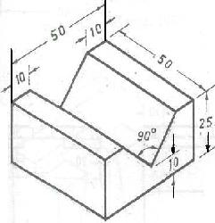 | 5 | 3 |  | 14
8 | Draw the front view, top view & side view of the given object  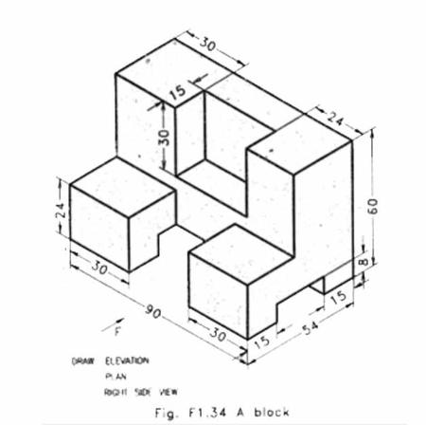 | 5 | 2 |  | 14
9 | Draw the front view, top view & side view of the given object  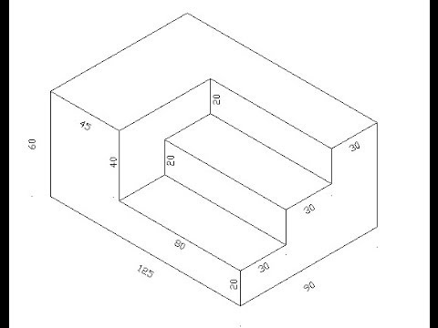 | 5 | 2 |  | 14
10 | Draw the front view, top view & side view of the given object  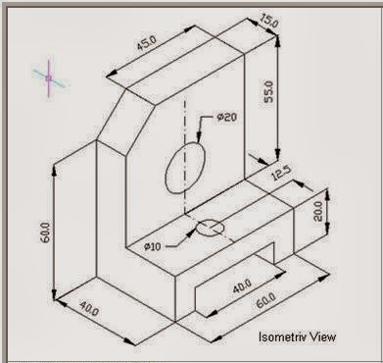 | 5 | 3 |  | 14
11 | Draw the front view, top view & side view of the given object  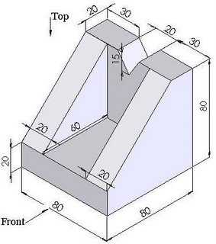 | 5 | 3 |  | 14
12 | Draw the front view, top view & side view of the given object  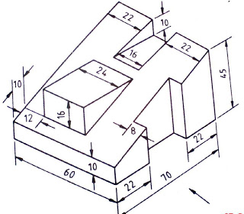 | 5 | 3 |  | 14

